OpenHIE Shared Health Records

Functional Specification

Version 1.1 (Draft)

Draft Editor(s): Brian Armstrong, Carl Fourie

Last Update: October 19, 2016

Table of Contents
Introduction 3
Purpose 3
Scope 3
1. SHR Level 1 4
2. SHR Level 2 4
3. SHR Level 3 4
Architecture Overview 5
OpenHIE Architecture 5
Shared Health Record Architecture Considerations 7
Security Architecture for the Shared Health Record 8
Use Cases 9
Primary 9
Secondary 9
Workflows 9
Interfaces / Interactions 16
Standards Catalog 29
Functional Requirements 31
Nonfunctional Requirements 39
Privacy and Security 44
OpenHIE's Basic Privacy & Security Behavior 44
Privacy 44
Security in the Shared Health Record 45
Privacy and Security References 46
References 47
Appendix 1: What data should the SHR Store? 48
Appendix 2: CDA and the SHR 49
SHR Implemented Section Templates of CDA 50
Appendix 3: FHIR and XDS.b Functionality 51

Introduction
This document serves as the OpenHIE (Open Health Information Exchange) Shared Health Records Requirements Specification (SHR-RS), and can be used by the OpenHIE Community and Implementers at the National, District, and Facility levels to ensure that their efforts are modeled on the SHR reference architecture.
An SHR is a means of allowing different health information systems to share information. For the purposes of OpenHIE, the SHR is viewed as a centralized data repository for storing patient’s shared health record
The SHR-RS provides a detailed specification of Use Cases, Requirements, Workflows, and Transactions, and will include examples of interactions useful for understanding the use cases, but will not be functionally complete. Please join in the Developer | DevOps Community Calls to participate with other members in development related dialogue.
Within the OpenHIE project there are two core functions that a Shared Health Record (SHR) should perform:
- The SHR should receive and store clinical documents for patients and respond to queries to retrieve a patient’s clinical documents.
- The SHR should be able to respond to queries for existing data about a patient that was received from the clinical documents.
In addition, there is a third function that could be considered ‘core’ in its own right, though it can be debated that it is simply a form of a query, and therefore should be contained with the core Query function:
- The SHR should be able to response to queries for aggregate data for reporting and analytics purposes.
Most other functions within the SHR can be categorized under these two core Save & Query functions, and this specification documents these in detail.
The SHR-RS should supersede any previous documentation where the term “requirements” has been used to define an SHR, and where it is required to have additional requirements, these would be added to a particular implementation initiative as custom additions in order for the requirements defined herein to be the intact single source of truth for the SHR.

Purpose
TBD

Scope
This section contains a brief description of the scope of the document. If the SRS is a complete description of the software, then it will state something similar to: “This document contains a complete description of the functionality of the (name of project) project. It consists of use cases, functional requirements and nonfunctional requirements, which, taken together form a complete description of the software.” For complex software, the requirements for the project might be divided into several SRS documents. In this case, the scope should indicate which portion of the project is covered in this document.
As defined by the OpenHIE Community, there are three levels for an SHR implementation, which are:

SHR Level 1
Inclusion: At least one IHE content profile + Query for Existing Data (QED)
A phase 1 OpenHIE SHR must implement the following:
- XDS.b's provide and register document, stored query and retrieve document transactions
- At least one of the Patient Care Coordination CDA content profiles which profile the CDA Continuity of Care Document (CCD) specification.
- The Query for Existing Data (QED) profile

SHR Level 2
Inclusion: All IHE PCC content profiles + Query for Existing Data (QED) + Referrals
A phase 2 OpenHIE SHR must implement the following:
- XDS.b's provide and register document, stored query and retrieve document transactions
- ALL of the Patient Care Coordination CDA content profiles which profile the CDA Continuity of Care Document (CCD) specification.
- The Emergency Department Referral (EDR) PCC profile which supports referrals
- The Query for Existing Data (QED) profile

SHR Level 3
Inclusion: Clinical documents + Query for Existing Data (QED) + Referrals + Some form of data export - [perhaps lab and drug profiles]
A phase 3 OpenHIE SHR must implement the following:
- XDS.b's provide and register document, stored query and retrieve document transactions
- ALL of the Patient Care Coordination CDA content profiles which profile the CDA Continuity of Care Document (CCD) specification.
- The Emergency Department Referral (EDR) PCC profile which supports referrals
- The Query for Existing Data (QED) profile
- A to-be-determined mechanism to export data for reporting purposes

Architecture Overview
The OpenHIE Architecture is composed of the OpenHIE Component Layer (e.g. Client Registry, Facilities Registry, Shared Health Record, etc.) which is connected to External Systems for data exchange through the Interoperability Services Layer also known as an ‘enterprise services bus’ or ESB.
This Specifications document concerns itself with the Shared Health Record (SHR) component of the OpenHIE Architecture, but for framing the SHR we include a brief overview of the OpenHIE Architecture, followed by the Workflows, Interfaces, and Functional Requirements of the SHR within the OpenHIE Framework.

OpenHIE Architecture
OpenHIE’s architecture is made up of six open-source software components, all interacting/interoperating to ensure that health information from various external systems is gathered into a unified person-centric medical record.
To accomplish this, the exchange normalizes the context in which health information is created across four dimensions:
- Who received health services,
- Who provided those services,
- Where did they receive the services, and
- What specific care did they receive.
By focusing on the “For Whom”, “By Whom”, “Where”, and “What” of a patient's health visit we help to bring relevant information directly to the point of care. This supports enhanced decision-making, improves the quality, safety and continuity of care, and facilitates the appropriate use of information to improve population health.
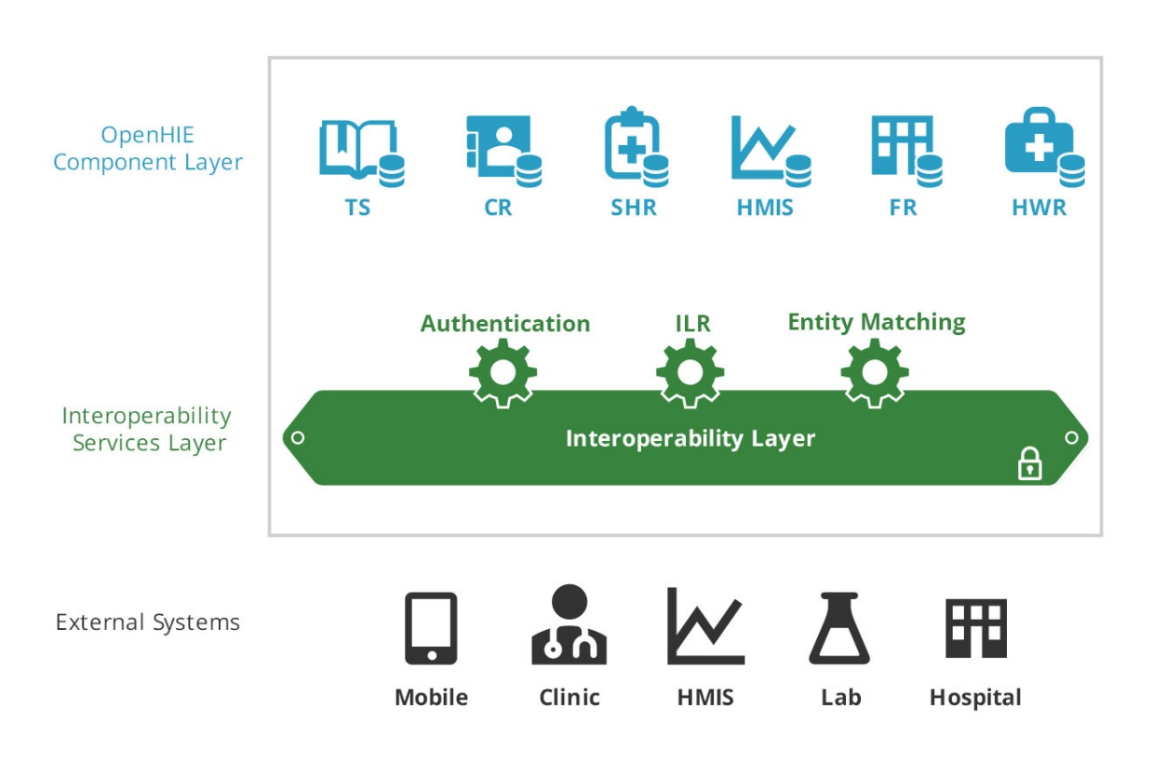
Figure 1 - OpenHIE Architecture Model
- A Terminology Service serves as a central authority to uniquely identify the clinical activities that occur within the care delivery process by maintaining a terminology set mapped to international standards such as ICO10, LOINC, SNOMED, and others – “What?”
- An enterprise master patient index (EMPI), or Client Registry manages the unique identity of citizens receiving health services with the country – “For whom"
- A Shared Health Record (SHR) is a repository containing the normalized version of content created within the community, after being validated against each of the previous registries. It is a collection of person-centric records for patients with information in the exchange.
- A Health Management Information System (HMIS) stores routinely-collected aggregate health care data, and facilitates their analysis with the goal of improving the quality of health services.
- A Health Facility Registry serves as a central authority to uniquely identify all places where health services are administered within the country – “Where?”
- A Health Worker Registry is the central authority for maintaining the unique identities of health providers within the country – “By whom"
- A Health Interoperability Layer receives all communications from external services within a health geography, and orchestrates message processing among the external systems and the OpenHIE component layer.
- External systems, such as the OpenMRS electronic medical records (EMR) system and the RapidSMS mHealth application, are used by clinicians and by community health workers to access and update a patient’s person-centric shared health information and to record healthcare transactions.

Shared Health Record Architecture Considerations
The SHR is expected to be deployed as a component within a larger OpenHIE infrastructure.
The SHR does not need to support functions such as patient id mapping or terminology mapping for independent support though; since such functions are envisioned as being provided by the HIE.
The main consideration is that the integrity of this specification be maintained by exchanging data and messages through the core functions (query, save) as described in Workflows and Interactions.
A high-level example of an implementation of an SHR is shown in the following diagram, showing OpenMRS as the data store for the SHR.

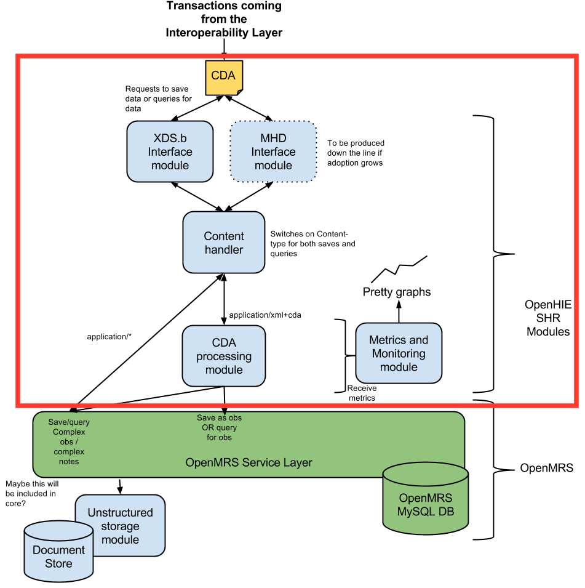
Figure 2 - Example of Using OpenMRS as an SHR
A shared health record is normalised if all metadata items such patient, provider and facility identifiers are resolved to appropriate universal identifiers (as opposed to their local identifiers as used by a client system). In addition all terminology codes in use need to be mapped to an appropriate reference terminology or SHR extensions to reference terminologies, if needed to fill coverage gaps for concepts relevant to SHR.

Security Architecture for the Shared Health Record
The SHR is typically expected to be implemented as a component within an overall OpenHIE framework, and thus utilizes the authentication and authorization functions of the IL or Interoperability Layer. If implementers choose not to use the IL then IL-like functions will need to be implemented in order to maintain the integrity of this Specification.
It is understood that the PHI of a patient needs to be protected by Security and Privacy constraints that enforce a Policy and Legislative framework of an implementing country, and that all users and systems connect to a trust relationship through the IL Core for Authentication, and the IL RBAC for authorization.

The IL Core (Authentication)
The OpenHIE framework utilizes IHE’s ATNA or Audit Trail and Node Authentication Integration Profile for authentication between a connecting system or user and the IL. Any system requiring access to the SHR will need to implement the ATNA Integration Profile in order to provide a trusted user access to PHI of the patient.
The ATNA Integration Profile contains:
- User Authentication: A POS purports an authenticated user to the IL and the IL accepts as true since only trusted parties can connect to the IL.
- Connection Authentication: Bi-directional certificate-based node authentication for connections to and from each node.
- Audit Trails:

The IL RBAC (Authorisation)
Authorization is establishing, for a known party, what it is that they are allowed to do or are allowed to see.
A consent directive that is more finely grained than all-access / no-access will rely on the authenticated identity of subjects of care, providers of care, or both – so that authority to access PHI can be established. Even role-based access control (RBAC) relies on establishing identity since the role is an attribute of the identity.

Common Message Security
The Common Message Security workflow describes the authentication and authorization of systems through the HIE Interoperability Layer. This workflow provides the security underpinning for many other workflows that rely on a secure connection and authorized message delivery. The Common Message Security workflow is a realization of the ATNA Integration Profile, which the SHR requires for secure access to PHI data.
In order to be approved a PoS or Point of Sale application must be approved through an MoH policy to be a “trusted” connection to the HIE. If the PoS doesn’t yet have a certificate and key, then the PoS application is registered with the IL and a certificate and key are generated by the IL and provided to the PoS admin to load into their system. If the PoS already has a certificate registered, then the IL is contacted to upload the existing PoS certificate.
The main message flow occurs when the PoS application sends a secure message using TLS mutual authentication, and the client certificate is validated to authenticate the PoS application. Internal operations within the IL then perform checks and validations to determine if the PoS has the authority to send this message and if the validations are successful the message is forwarded for delivery to the internal HIE component (e.g. CR, FR, SHR, etc.), and any returned messages delivered to the PoS application.

Use Cases

Primary
- A point-of-care system (i.e., LIMS, EMR, etc.) should be able to store a normalised subset of clinical information items (that which is deemed appropriate to share) from a patient’s clinical record on that system.
  - We should be able to store Observations, Allergies, Care Summaries, Care Plans etc. See What data should the SHR store? in Appendix 1.
  - Store unstructured data along with associated metadata, e.g. a PDF document or digital image with attached patient demographic information
- A client system should be able to retrieve relevant portions (up to the full set) of this clinical record as needed.
  - Retrieve a longitudinal list of patient clinical information by type, date or other query parameters
- A client system should be able to update existing clinical records while keeping the version history
- System should acknowledge requests from a client system and provide appropriate information in the event of errors
- The system should be validated against the health needs of low resource settings, e.g. HIV, TB, Maternal Care.

Secondary
- Data should be available for extraction for secondary use.

Workflows
The Shared Health Record consists of a subset of workflows within the OpenHIE Framework, specifically:
- Save patient-level clinical data workflow – V2.0
- Query patient-level data workflow – v2.0
- Query for Aggregate data from the SHR
- Aggregate data exchange from patient level system to HMIS

WF.001: Save patient-level clinical workflow – V2.0
Name | Workflow number and name
Workflow Name: | Save patient-level clinical data workflow – V2.0
Summary | This transaction allows a point of service (PoS) system to save patient-level clinical data to the SHR. The transaction is verified and validated against the other registries before it is saved in the SHR.
Status | In Progress
Rationale | Description of the reason that the workflow is needed
Diagram | 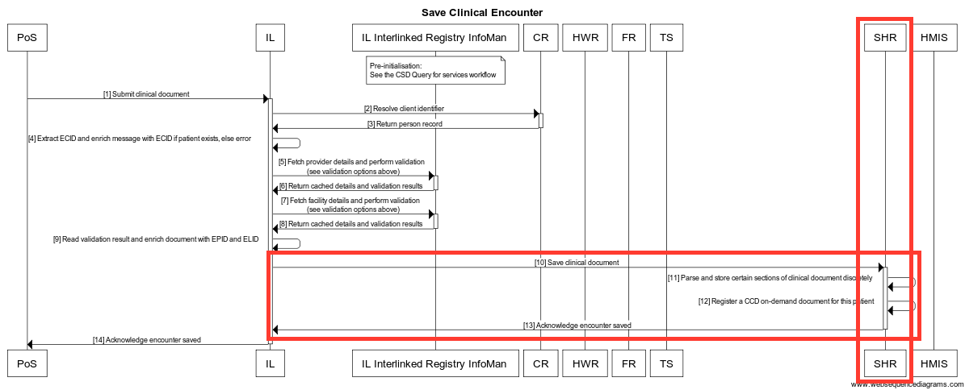
Actors | - All  - PoS  - CR  - IL  - SHR  - SHR specific (actors SHR engages with)  - IL
Assumptions /  Prerequisites | - The IL should validate the clinical document before it can be saved to the SHR. There are some key validations that are always required and the transaction should fail if these are not met.  - The PoS system has a curated list of Providers that interact with that system, with knowledge of at least the providers that are relevant to that PoS system.  - The PoS system has a curated list of Facilities that this system serves, with knowledge of at least one member (itself).  - The PoS system must ensure the patient they are submitting clinical information about already exists. It can do this by querying for the patient (Query patient demographic records by demographics workflow - V1.0) and if they don't exist they should register them (Create patient demographic record workflow - V1.0).  - The PoS system is a trusted application known by the HIE and it is registered with the interoperability layer to be able to send and receive data securely (Common message security workflow).  - The conditions for the validation of facility, provider and services are configurable to enable them to be more or less strict.  - All XDS submissions to the OpenHIM MUST contain author information. Either authorPerson or authorInstitution or both MUST be supplied. When supplying these, they MUST be supplied is full XCN/XON format and these MUST include an identifier component. This requirement is more restrictive that the XDS.b profile however it is required in order to perform validation of the health worker and facility submitting this information.  - The SHR MUST be able to store certain sections of a CDA document as discrete data in its internal data model for use when generating on-demand documents. The section that are to be supported for discrete import those defined in the XDS-MS specification as well as (optionally) any other section that are deemed useful within the environment in which the SHR is deployed.
Validations | These are base validations that must always take place:  - The client (patient) is known and has an enterprise client id (ECID).  - The facility is valid and operational and can be uniquely identified with an enterprise location id (ELID).  - The provider is valid and currently practicing and can be uniquely identified with an enterprise provider id (EPID).  There are also additional optional validations that may be beneficial for more advanced HIEs where the information is available. Implementation can also come up with other validation that make sense to their environment. These validations should not fail the transaction but rather be logged as warnings for a HIE admin to check up on:  - The provider currently works at the facility  - The provider currently provides the service requested at the facility  - The service is allowed at the facility
Basic Course of Events  (Interactions) | - Submit clinical encounter (POS-to-IL)  - Resolve client identifier (IL-to-CR)  - Return person record (CR-to-IL)  - Extract ECID and enrich message with ECID if patient exists, else error (IL)  - Fetch provider details and perform validation (IL-to-ILR)  - Return cached details and validation results (ILR-to-IL)  - Fetch facility details and perform validation (IL-to-ILR)  - Return cached details and validation results (ILR-to-IL)  - Read validation result and enrich document with EPID and ELID (IL)  - Save clinical document (IL-to-SHR)  - Parse and store certain sections of clinical document discretely ([SHR] internal operation)  - Register a CCD on-demand document for this patient (SHR)  - Acknowledge encounter saved (SHR-to-IL)  - Acknowledge encounter saved (IL-to-POS)  SHR Specific Events:  - Save clinical document  - Register a CCD on-demand document for this patient  - Acknowledge encounter saved
Alternative Paths | Conditions under which the basic course of events could change
Postconditions | The state of the software after the basic course of events is complete

WF.002: Query patient-level clinical workflow – V2.0
Name | Workflow number and name
Workflow Name: | Query patient-level clinical data workflow – V2.0
Summary | The transaction queries for previously stored clinical data for a specific patient. The following sequence diagram shows the steps involved in this transaction.
Status | In Progress
Rationale | Description of the reason that the workflow is needed
Diagram | 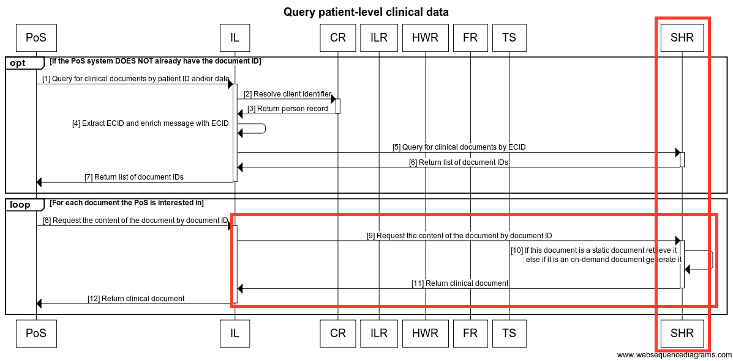
Actors | - All  - IL  - SHR  - SHR specific (actors SHR engages with)  - IL
Assumptions /  Prerequisites | - The PoS system must ensure the patient they are querying clinical information about already exists. It can do this by querying for the patient (Query patients workflow).  - The PoS system is a trusted application known by the HIE and it is registered with the interoperability layer to be able to send and receive data securely (Common message security workflow).
Validations | These are base validations that must always take place:  - The client (patient) is known and has an enterprise client id (ecid).  - The facility is valid and operational and can be uniquely identified with an enterprise location id (elid).  - The provider is valid and currently practising and can be uniquely identified with an enterprise provider id (epid).
Basic Course of Events  (Interactions) | - Query for clinical documents by patient ID and/or date (POS-to-IL)  - Resolve client identifier (IL-to-CR)  - Return person record (CR-to-IL)  - Extract ECID and enrich message with ECID (IL)  - Query for clinical documents by ECID (IL-to-SHR)  - Return list of document IDs (SHR-to-IL)  - Return list of document IDs (IL-to-POS)  Loop:  - Request the content of the document by document ID (POS-to-IL)  - Request the content of the document by document ID (IL-to-SHR)  - Retrieve Static Document, else Generate ODD ([SHR] internal operation)  - Return clinical document (SHR-to-IL)  - Return clinical document (IL-to-POS)  SHR Specific Events:  - Query for clinical documents by ECID (IL-to-SHR)  - Return list of document IDs (SHR-to-IL)  - Request the content of the document by document ID (IL-to-SHR)  - Retrieve Static Document, else Generate ODD  - Return clinical document (SHR-to-IL)
Alternative Paths | Conditions under which the basic course of events could change
Postconditions | The state of the software after the basic course of events is complete

WF.003: Aggregate data from the SHR
Name | Workflow number and name
Workflow Name: | Aggregate data from the SHR
Summary | This workflow will enable the Shared Health Record to be able to export aggregate data to the HMIS systems so that it can be used for reporting purposes.
Status | Proposed (see comments at bottom of Wiki page for Workflow link above for further discussion.)
Rationale | Description of the reason that the workflow is needed
Diagram | 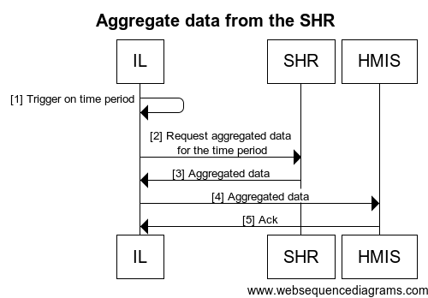
Actors | - All  - IL  - SHR  - HMIS  - SHR specific (actors SHR engages with)  - IL
Assumptions /
Prerequisites
Validations
Basic Course of Events  (Interactions) | - Trigger on time period (IL)  - Request aggregated data for the time period (IL-to-SHR)  - Aggregated data (SHR-to-IL)  - Aggregated data (IL-to-HMIS)  - Ack (HMIS-to-IL)  SHR events  - Request aggregated data for the time period  - Aggregated data
Alternative Paths | Conditions under which the basic course of events could change
Postconditions | The state of the software after the basic course of events is complete
Warnings: | This workflow is currently specific to DHIS2 as the HMIS and OpenMRS as the SHR, in future iterations it may change to incorporate a more standard based approach.

WF.004: Aggregate data exchange from patient level to HMIS (POS/SHR)
Name | Workflow number and name
Workflow Name: | Aggregate data exchange from patient level to HMIS (POS/SHR)
Summary | This workflow describes aggregate data exchange from patient level system to HMIS using ADX profile. The use case for this workflow is based on DATIM, where aggregate data is created in a POS or SHR.
Status | Proposed
Rationale | Description of the reason that the workflow is needed
Diagram | 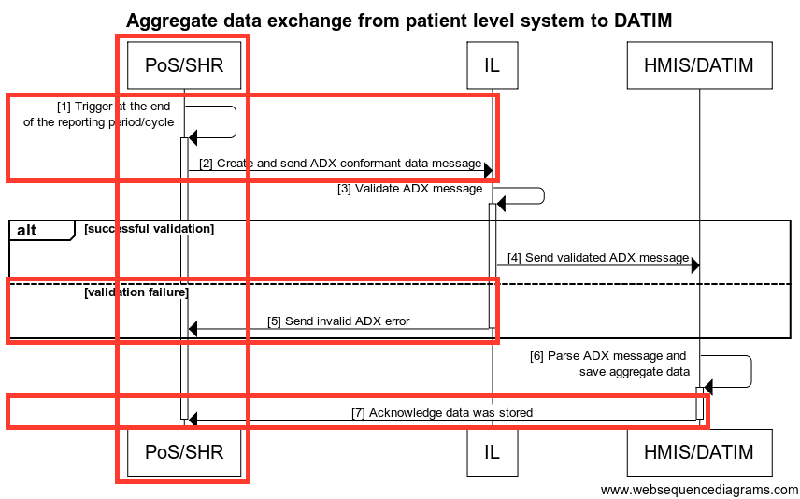
Actors | - All  - IL  - POS/SHR  - HMIS/DATIM  - SHR specific (actors SHR engages with)  - IL  - HMIS/DATIM
Assumptions /  Prerequisites | - The workflow presumes that the metadata (facilities, mechanisms and indicator data elements) to facilitate data exchange have been mapped/configured in both systems.
Validations
Basic Course of Events  (Interactions) | - Trigger at the end of the reporting period/cycle (POS/SHR)  - Send ADX conformant data message (POS/SHR-to-IL)  - Validate ADX message (IL)  - Send validated ADX message (IL-to-HMIS/DATIM)  - Send invalid ADX error (IL-to-POS/SHR)  - Parse ADX message and save aggregate data (HMIS/DATIM)  - Acknowledge data was stored (HMIS-to-POS/SHR)  SHR Events:  - Trigger at the end of the reporting period/cycle  - Send ADX conformant data message  - Send invalid ADX error  - Acknowledge data was stored
Alternative Paths | Conditions under which the basic course of events could change
Postconditions | The state of the software after the basic course of events is complete
Warnings:

Interfaces / Interactions
Interfaces designed for OpenSHR support HL7v3 CDA ‘on demand’ documents, MHD, and IHE XDS.b profiles.

# | Interface | Standards | Workflow (reference)
I.001 | Request aggregated data for the time period | <<tbd>> | Aggregate data from the SHR
I.002 | Return Aggregated data | ADX | Aggregate data from the SHR
I.003 | Query for clinical documents by ECID | XDS.b  FHIR | Query patient-level clinical data workflow – V2.0
I.004 | Return list of document IDs | XDS.b  FHIR | Query patient-level clinical data workflow – V2.0
I.005 | Request the content of the document by document ID | XDS.b  FHIR | Query patient-level clinical data workflow – V2.0
I.006 | Return clinical document | XDS.b  FHIR | Query patient-level clinical data workflow – V2.0
I.007 | Save clinical document | XDS.b  ITI-41  HL7v3 CDA (PCC profile specific)  FHIR | Save patient-level clinical data workflow – V2.0
I.008 | Register a CCD on-demand document for this patient | XDS.b | Save patient-level clinical data workflow – V2.0
I.009 | Acknowledge encounter save | ITI-41  ITI-65  FHIR | Save patient-level clinical data workflow – V2.0
I.010 | Trigger at the end of the reporting period/cycle |  | Aggregate data exchange from patient level to HMIS (POS/SHR)
I.011 | Create and send ADX conformant message | ADX | Aggregate data exchange from patient level to HMIS (POS/SHR)
I.012 | Send invalid ADX error |  | Aggregate data exchange from patient level to HMIS (POS/SHR)
I.013 | Acknowledge data was stored |  | Aggregate data exchange from patient level to HMIS (POS/SHR)
I.001: Request aggregated data for the time period
Interaction | I.001: Request aggregated data for the time period
Endpoint
Data | SQL
Transaction Specification
I.002: Return Aggregated data
Interaction | I.002: Return Aggregated data
Endpoint
Data | SQL result set
Transaction Specification
I.003: Query for clinical documents by ECID
Interaction | I.003: Query for clinical documents by ECID
Sections | I.003.1: Query for clinical documents by ECID (MHD)  I.003.2: Query for clinical documents by ECID (XDS.b)  I.003.3: Query for clinical documents by ECID (FHIR)
I.003.1: Query for clinical documents by ECID (MHD)
Interaction | I.003.1: Query for clinical documents by ECID (MHD)
Endpoint | MHD Find document references (ITI-67) - RESTful query  (only if SHR support MHD directly)
Data | MHD metadata
Transaction Specification | IHE IT Infrastructure  MHD: MHD profile supplement
I.003.2: Query for clinical documents by ECID (XDS.b)
Interaction | I.003.2: Query for clinical documents by ECID (XDS.b)
Endpoint | XDS.b Registry Stored Query (ITI-18) - Find Documents query
Data | XDS.b
Transaction Specification | IHE IT Infrastructure  Vol. 1 - Section 10, Appendix E, J, K  Vol. 2a - Sections 3.18  Vol. 2b - Sections 3.41, 3.42, 3.43  Vol. 2x - Appendix A, B, K, L, M, N, V, W  Vol. 3 - Section 4.1, 4.2, 4.3
I.003.3: Query for clinical documents by ECID (FHIR)
Interaction | I.003.3: Query for clinical documents by ECID (FHIR)
Endpoint | FHIR Stored Query - Find Documents query
Data | FHIR Documents
Transaction Specification | http://www.hl7.org/implement/standards/fhir/documents.html

I.004: Return list of document IDs
Interaction | I.004: Return list of document IDs
Sections | I.004.1: Return list of document IDs (MHD)  I.004.2: Return list of document IDs (XDS.b)  I.004.3: Return list of document IDs (FHIR)
I.004.1: Return list of document IDs (MHD)
Interaction | I.004.1: Return list of document IDs (MHD)
Endpoint
Data | MHD Find document references response - list of document IDs  (only if SHR support MHD directly)
Transaction Specification | IHE IT Infrastructure  MHD: MHD profile supplement
I.004.2: Return list of document IDs (XDS.b)
Interaction | I.004.2: Return list of document IDs (XDS.b)
Endpoint
Data | XDS.b Registry Stored Query response - list of document IDs
Transaction Specification | IHE IT Infrastructure  Vol. 1 - Section 10, Appendix E, J, K  Vol. 2a - Sections 3.18  Vol. 2b - Sections 3.41, 3.42, 3.43  Vol. 2x - Appendix A, B, K, L, M, N, V, W  Vol. 3 - Section 4.1, 4.2, 4.3
I.004.2: Return list of document IDs (XDS.b)
Interaction | I.004.2: Return list of document IDs (XDS.b)
Endpoint
Data | XDS.b Registry Stored Query response - list of document IDs
Transaction Specification | IHE IT Infrastructure  Vol. 1 - Section 10, Appendix E, J, K  Vol. 2a - Sections 3.18  Vol. 2b - Sections 3.41, 3.42, 3.43  Vol. 2x - Appendix A, B, K, L, M, N, V, W  Vol. 3 - Section 4.1, 4.2, 4.3
I.004.3: Return list of document IDs (FHIR)
Interaction | I.004.3: Return list of document IDs (FHIR)
Endpoint | FHIR Documents
Data | FHIR Stored Query response - list of document IDs  NOTE: Does FHIR provide a call to return list of document IDs (e.g. masterIdentifer)?
Transaction Specification | IHE IT Infrastructure  Vol. 1 - Section 10, Appendix E, J, K  Vol. 2a - Sections 3.18  Vol. 2b - Sections 3.41, 3.42, 3.43  Vol. 2x - Appendix A, B, K, L, M, N, V, W  Vol. 3 - Section 4.1, 4.2, 4.3

I.005: Request the content of the document by document ID
Interaction | I.005: Request the content of the document by document ID
Sections | I.005.1: Request the content of the document by document ID (MHD)  I.005.2: Request the content of the document by document ID (XDS.b)  I.005.3: Request the content of the document by document ID (FHIR)
I.005.1: Request the content of the document by document ID (MHD)
Interaction | I.005.1: Request the content of the document by document ID (MHD)
Endpoint | MHD Retrieve document (ITI-68)
Data | MHD metadata
Transaction Specification | IHE IT Infrastructure  MHD: MHD profile supplement
I.005.2: Request the content of the document by document ID (XDS.b)
Interaction | I.005.2: Request the content of the document by document ID (XDS.b)
Endpoint | XDS.b Retrieve Document Set (ITI-43)
Data | XDS.b  NOTE:  - Return CDA documents by template (see Appendix 2 for template types)  - To return CDA on-demand documents (sections) – Requires registration of OnDemandDocumentRegistration information for interface call so that data store can determine how it should generate the document.
Transaction Specification | IHE IT Infrastructure  - Vol. 1 - Section 10, Appendix E, J, K  - Vol. 2a - Sections 3.18  - Vol. 2b - Sections 3.41, 3.42, 3.43  - Vol. 2x - Appendix A, B, K, L, M, N, V, W  - Vol. 3 - Section 4.1, 4.2, 4.3
I.005.3: Request the content of the document by document ID (FHIR)
Interaction | I.005.3: Request the content of the document by document ID (FHIR)
Endpoint | FHIR DocumentReference
Data | FHIR Document  Need clarification here: Can the masterIdentifier of the DocumentReference be used in this context and with this interface request?
Transaction Specification | FHIR DocumentReference  FHIR Documents
I.006: Return clinical document
Interaction | I.006: Return clinical document
Sections | I.006.1: Return clinical document (MHD)  I.006.2: Return clinical document (XDS.b)  I.006.3: Return clinical document (FHIR)  I.006.4: Return clinical document (Static)  I.006.5: Return clinical document (ODD)
I.006.1: Return clinical document (MHD)
Interaction | I.006.1: Return clinical document (MHD)
Endpoint
Data | MHD response - with CDA document content
Transaction Specification
I.006.2: Return clinical document (XDS.b)
Interaction | I.006.2: Return clinical document (XDS.b)
Endpoint
Data | XDS.b  NOTE:  - Return CDA documents by template
Transaction Specification | https://wiki.ohie.org/display/SUB/On+Demand+Documents+Module
I.006.3: Return clinical document (FHIR)
Interaction | I.006.3: Return clinical document (FHIR)
Endpoint
Data | FHIR Document
Transaction Specification | FHIR DocumentReference  FHIR Documents
I.006.4: Return clinical document (Static)
Interaction | I.006.4: Return clinical document (Static)
Endpoint
Data | FHIR Document
Transaction Specification | FHIR DocumentReference  FHIR Documents

I.006.5: Return clinical document (ODD)
Interaction | I.006.5: Return clinical document (ODD)
Endpoint
Data | On-Demand CDA  NOTE:  - Return CDA on-demand documents (sections) – Requires registration of OnDemandDocumentRegistration (may be OpenMRS specific function) information for interface call so that data store can determine how it should generate the document.
Transaction Specification | XDS-MS Specification

I.007: Save clinical document
Interaction | I.007: Save clinical document
Sections | I.007.1: Save clinical document (MHD)  I.007.2: Save clinical document (XDS.b)  I.007.3: Save clinical document (FHIR)
I.007.1: Save clinical document (MHD)
Interaction | I.007.1: Save clinical document (MHD)
Endpoint | MHD provide document bundle (ITI-65) - RESTful FHIR interface
Data | CDA document conforming to a particular PCC profile
Transaction Specification | IHE IT Infrastructure  MHD: MHD profile supplement
I.007.2: Save clinical document (XDS.b)
Interaction | I.007.2: Save clinical document (XDS.b)
Endpoint | XDS.b provide and register document (ITI-41 from the ITI framework) - SOAP web service
Data | CDA document conforming to a particular PCC profile
Transaction Specification | IHE IT Infrastructure  - Vol. 1 - Section 10, Appendix E, J, K  - Vol. 2a - Sections 3.18  - Vol. 2b - Sections 3.41, 3.42, 3.43  - Vol. 2x - Appendix A, B, K, L, M, N, V, W  - Vol. 3 - Section 4.1, 4.2, 4.3
I.007.3: Save clinical document (FHIR)
Interaction | I.007.3: Save clinical document (FHIR)
Endpoint | FHIR Documents
Data | FHIR Documents
Transaction Specification | http://www.hl7.org/implement/standards/fhir/documents.html
I.008: Register a CCD on-demand document for this patient
Interaction | I.008: Register a CCD on-demand document for this patient
Endpoint | XDS.b register document set (ITI-42 from the ITI framework) - SOAP web service
Data | Generated metadata  NOTE:  - To register that an ODD is available the OnDemandDocumentService needs to receive a registration of an ODD and persist the registration to the data store, performing the necessary steps to coqnvey this data to the XDS Registry.
Transaction Specification | IHE IT Infrastructure  - Vol. 1 - Section 10, Appendix E, J, K  - Vol. 2a - Sections 3.18  - Vol. 2b - Sections 3.41, 3.42, 3.43  - Vol. 2x - Appendix A, B, K, L, M, N, V, W  - Vol. 3 - Section 4.1, 4.2, 4.3  XDS-MS specification  On-Demand Documents Module
I.009: Acknowledge encounter save
Interaction | I.009: Acknowledge encounter save
Section | I.009.1: Acknowledge encounter save (ITI-41)  I.009.2: Acknowledge encounter save (ITI-65)  I.009.3: Acknowledge encounter save (FHIR)

I.009.1: Acknowledge encounter save (ITI-41)
Interaction | I.009.1: Acknowledge encounter save (ITI-41)
Endpoint
Data | ITI-41 SOAP response
Transaction Specification | IHE IT Infrastructure  - Vol. 1 - Section 10, Appendix E, J, K  - Vol. 2a - Sections 3.18  - Vol. 2b - Sections 3.41, 3.42, 3.43  - Vol. 2x - Appendix A, B, K, L, M, N, V, W  - Vol. 3 - Section 4.1, 4.2, 4.3  XDS-MS specification
I.009.2: Acknowledge encounter save (ITI-65)
Interaction | I.009.2: Acknowledge encounter save (ITI-65)
Endpoint
Data | ITI-65 RESTful response
Transaction Specification | IHE IT Infrastructure  - Vol. 1 - Section 10, Appendix E, J, K  - Vol. 2a - Sections 3.18  - Vol. 2b - Sections 3.41, 3.42, 3.43  - Vol. 2x - Appendix A, B, K, L, M, N, V, W  - Vol. 3 - Section 4.1, 4.2, 4.3  XDS-MS specification

I.009.3: Acknowledge encounter save (FHIR)
Interaction | I.009.3: Acknowledge encounter save (FHIR)
Endpoint
Data | FHIR DocumentReference?
Transaction Specification

I.010: Trigger at the end of the reporting period/cycle
Interaction | I.010: Trigger at the end of the reporting period/cycle
Endpoint | POS/SHR
Data
Transaction Specification
I.011: Create and send ADX conformant data message
Interaction | I.011: Create and send ADX conformant data message
Endpoint | IL
Data
Transaction Specification | IHE Quality, Research and Public Health Technical Framework Supplement: Aggregate Data Exchange (ADX)
I.012: Send invalid ADX error
Interaction | I.012: Send invalid ADX error
Endpoint | POS/SHR
Data | ACK
Transaction Specification
I.013: Acknowledge data was stored
Interaction | I.012: Acknowledge data was stored
Endpoint | POS/SHR
Data
Transaction Specification

Standards Catalog
Standards related to the Shared Health Record include…
Key criteria for SHR standards:
- Easily Implementable - The standard should be easy to implement in point of care systems and within the HIE as countries will have to support and maintain these with a low number of skilled informatics specialists.
- Size efficient - The messages should be size efficient due to possible bandwidth restrictions in low resource settings.
- Understandable - The standard should be easily understandable and not require informatics professionals to work with the standard or understand the standard.
- Mature tooling - The standard should have some mature tooling to assist application to implement the needed functionality.
- We can influence the standards - It is important that we as the OpenHIE community can influence the standards development organizations such that the needs of low resource setting can be fully realised and met.

Current SHR Standards are listed as:

# | Standard | Interfaces / Interactions
1 | ADX | I.011: Create and send ADX conformant data message
2 | CDA | I.007.1: Save clinical encounter (MHD)  I.007.2: Save clinical encounter (XDS.b)
3 | FHIR | I.003.3: Query Clinical Documents by ECID (FHIR)  I.004.3: Return List of Document IDs (FHIR)  I.005.3: Request the content of the document by document ID (FHIR)  I.006.3: Return Clinical Document (FHIR)  I.007.3: Save clinical document (FHIR)  I.009.3: Acknowledge Encounter Save (FHIR)
4 | MHD | I.003.1: Query for clinical documents by ECID (MHD)  I.004.1: Return list of document IDs (MHD)  I.005.1: Request the content of the document by document ID (MHD)  I.006.1: Return clinical document (MHD)  I.007.1: Save clinical Encounter (MHD)
5 | XDS.b | I.003.2: Query for clinical documents by ECID (XDS.b)  I.004.2: Return list of document IDs (XDS.b)  I.005.2: Request the content of the document by document ID (XDS.b)  I.006.2: Return clinical document (XDS.b)  I.007.2: Save clinical Encounter (XDS.b)  I.008: Register a CCD on-demand document for this patient  I.009.1: Acknowledge Encounter Save (ITI-41)  I.009.2: Acknowledge Encounter Save (ITI-65)

Alternative and existing standards that are proposed to be reviewed for the SHR are:
- Custom profiles of HL7 v2
- Custom profiles of HL7 v3
- IHE profiles
- FHIR profiles

Functional Requirements
Functional requirements define the internal workings of the software: that is, the calculations, technical details, data manipulation and processing, and other specific functionality that shows how the use cases are to be satisfied.

Complete list of Functional Requirements
Name
- FR-1: Stores unstructured clinical data
  - FR-1.1: Stores Images
  - FR-1.2: Stores Narrative Text
  - FR-1.3: Stores PDFs
- FR-2: Stores structured clinical data
  - FR-2.1: Stores clinical data in a structured form - FHIR
  - FR-2.2: Stores clinical data in a structured form – HL7v2
- FR-3: Stores data in a form that contains both structured and unstructured elements
- FR-4: Can return documents for a patient
  - FR-4.1: Can return a list of documents for a patient (as it was submitted)
  - FR-4.2: Can return a specific document for a patient
- FR-5: Can return a list of discrete observations for a patient satisfying specific query parameters
- FR-6: Keeps audit logs of any clinical and demographic data that is stored or changed.
- FR-7: Records and versions updates
- FR-8: Ability to export data for secondary use
- FR-9: Provides interfaces/extension points at various stages of the data lifecycle
- FR-10: Should allow for storage and retrieval of basic privacy/policy constraints
- FR-11: Must be able to store observational data mapped to standard reference terminology
- FR-12: Generation of Clinical Documents
  - FR-12.1: Generation of Clinical Documents (CDA)
  - FR-12.2: Generation of Clinical Documents (MHD)
  - FR-12.3: Generation of Clinical Documents (XDS)
- FR-13: The system needs to identify patients via a universal system identifier

FR-1: Stores unstructured clinical data
Name | FR-1: Stores unstructured clinical data
Summary
Sections | FR-1.1: Stores Images  FR-1.2: Stores Narrative Text  FR-1.3: Stores PDFs
Enabling Workflows: | Save patient-level clinical data workflow – V2.0
FR-1.1: Stores Images
Name | FR-1.1: Stores Images
Summary
Rationale
Requirements
Enabling Workflows: | Save patient-level clinical data workflow – V2.0
References
FR-1.2: Stores Narrative Text
Name | FR-1.2: Stores Narrative Text
Summary
Rationale
Requirements
Enabling Workflows: | Save patient-level clinical data workflow – V2.0
References
FR-1.3: Stores PDFs
Name | FR-1.3: Stores PDFs
Summary
Rationale
Requirements
Enabling Workflows: | Save patient-level clinical data workflow – V2.0
References

FR-2: Stores structured clinical data
Name | FR-2: Stores structured clinical data
Summary
Sections | FR-2.1: Stores clinical data in a structured form - FHIR  FR-2.2: Stores clinical data in a structured form – HL7v2
Enabling Workflows: | Save patient-level clinical data workflow – V2.0

FR-2.1: Stores clinical data in a structured form - FHIR
Name | FR-2.1: Stores clinical data in a structured form - FHIR
Summary
Rationale
Requirements
Enabling Workflows: | Save patient-level clinical data workflow – V2.0
References

FR-2.2: Stores clinical data in a structured form – HL7v2
Name | FR-2.2: Stores clinical data in a structured form – HL7v2
Summary
Rationale
Requirements
Enabling Workflows: | Save patient-level clinical data workflow – V2.0
References

FR-3: Stores data in a form that contains both structured and unstructured elements
Name | FR-3: Stores data in a form that contains both structured and unstructured elements
Summary
Rationale
Requirements
Enabling Workflows: | Save patient-level clinical data workflow – V2.0  Query patient-level clinical data workflow – V2.0
References

FR-4: Can return documents for a patient
Name | FR-4: Can return documents for a patient
Summary
Sections | FR-4.1: Can return a list of documents for a patient (as it was submitted)  FR-4.2: Can return a specific document for a patient
Requirements
Enabling Workflows: | Query patient-level clinical data workflow – V2.0

FR-4.1: Can return a list of documents for a patient (as it was submitted)
Name | FR-4.1: Can return a list of documents for a patient (as it was submitted)
Summary
Rationale
Requirements
Enabling Workflows: | Query patient-level clinical data workflow – V2.0
References

FR-4.2: Can return a specific document for a patient
Name | FR-4.2: Can return a specific document for a patient
Summary
Rationale
Requirements | FR-4.1: Can return a specific known document or a list of documents for a patient (as it was submitted)
Enabling Workflows: | Query patient-level clinical data workflow – V2.0
References

FR-5: Can return a list of discrete observations for a patient satisfying specific query parameters
Name | FR-5: Can return a list of discrete observations for a patient satisfying specific query parameters
Summary | Can return a list of discrete observations for a patient that satisfy specific query parameters. This data can subsequently be used for trending or providing the previous encounters that a patient has had.
Rationale
Requirements
Enabling Workflows: | Query patient-level clinical data workflow – V2.0
References

FR-6: Keeps audit logs of any clinical and demographic data that is stored or changed
Name | FR-6: Keeps audit logs of any clinical and demographic data that is stored or changed.
Summary | Keeps audit logs of any clinical and demographic data that is stored or changed. Logging who has accessed/viewed clinical information does NOT need to be stored, this is something that an interoperability layer could log.
Rationale
Requirements
Enabling Workflows:
References | - Clinical Document Architecture Support for OpenSHR: Auditing & Accountability: The ATNA module for OpenSHR allows it to produce RFC-3881 compliant audit messages whenever data is imported or exported to/from the OpenSHR data store respectively. These audits are collected in a central audit repository within the OpenHIE compliant Audit Repository  - Extract: XDS.b has very specific auditing requirements (ATNA) and for this we would need to send our auditing messages to an external repository. Another option would be to handle the auditing on the HIM side. Hannes Venter  - Extract: I'd like to draw out an important point that isn't immediately evident to a casual reader. Our message #1 – the inbound message from the point-of-care client to the interoperability layer (IL) – is a secured message from an authenticated sender to and authenticated recipient. The underlying requirements for an XDS.b transmission include mandatory support of IHE's audit trail and node authentication (ATNA) profile.  This mandatory support for ATNA means the IL doesn't talk to strangers and it means that a clinical document submission cannot be conducted "on the sly" without laying down an audit trail. Both of these attributes of the document submission are fundamental to supporting the security and privacy mandates that are found, in any jurisdiction, regarding the exchange of protected personal health information (PHI). Although it isn't explicitly called out as part of this workflow, it is a core functionality of the IL that is operationalizes the security, privacy and integrity of health data exchange. Derek Ritz (ecGroup)  - OpenHIE IHE Integration Statement

FR-7: Records and versions updates
Name | FR-7: Records and versions updates
Summary | Records and versions updates; records can never be deleted only marked as such, any previous update should be not rewrite old data, no information should ever be removed from the system.
Rationale
Requirements
Enabling Workflows:
References

FR-8: Ability to export data for secondary use
Name | FR-8: Ability to export data for secondary use
Summary
Rationale
Requirements
Enabling Workflows: | WF.003: Aggregate data from the SHR
References | OpenHIE Workflow: Aggregate data from the SHR  https://wiki.ohie.org/display/documents/Aggregate+data+from+the+SHR

FR-9: Provides interfaces/extension points at various stages of the data lifecycle
Name | FR-9: Provides interfaces/extension points at various stages of the data lifecycle
Summary | FR-9: Provides interfaces/extension points at various stages of the data lifecycle to allow for semantic validation or simple decision support
Rationale
Requirements
Enabling Workflows:
References

FR-10: Should allow for storage and retrieval of basic privacy/policy constraints
Name | FR-10: Should allow for storage and retrieval of basic privacy/policy constraints
Summary | Should allow for storage and retrieval of basic privacy/policy constraints (access control - restrict part of record and restrict entire record)
Rationale
Requirements
Enabling Workflows:
References

FR-11: Must be able to store observational data mapped to standard reference terminology
Name | FR-11: Must be able to store observational data mapped to standard reference terminology
Summary
Rationale
Requirements
Enabling Workflows: | WF.001: Save patient-level clinical workflow – V2.0
References | OpenHIE Workflow: Save patient-level clinical workflow – V2.0  https://wiki.ohie.org/display/documents/Save+patient-level+clinical+data+workflow+-+V2.0

FR-12: Generation of Clinical Documents
Name | FR-12: Generation of Clinical Documents
Summary | Section containing Clinical Document formats
Sections | FR-12.1: Generation of Clinical Documents (CDA)  FR-12.2: Generation of Clinical Documents (MHD)  FR-12.3: Generation of Clinical Documents (XDS)  FR-12.4: Generation of Clinical Documents (FHIR)
Enabling Workflows: | WF.002: Query patient-level clinical workflow – V2.0
References | OpenHIE Workflow: Query patient-level clinical workflow – V2.0  https://wiki.ohie.org/display/documents/Query+patient-level+clinical+data+workflow+-+V2.0

FR-12.1: Generation of Clinical Documents (CDA)
Name | FR-12.1: Generation of Clinical Documents (CDA)
Summary
Rationale
Requirements
References | See OpenSHR CDA Implementation for overview of CDA implementation as it exists within the OpenSHR Project.

FR-12.2: Generation of Clinical Documents (MHD)
Name | FR-12.2: Generation of Clinical Documents (MHD)
Summary
Rationale
Requirements
References | See IHE’s Mobile access to Health Documents (MHD) which currently has a Profile Status of Trial Implementation

FR-12.3: Generation of Clinical Documents (XDS)
Name | FR-12.3: Generation of Clinical Documents (XDS)
Summary
Rationale
Requirements | - Support XDS.b
References | See Introduction to Cross-enterprise Document Sharing

FR-12.4: Generation of Clinical Documents (FHIR)
Name | FR-12.4: Generation of Clinical Documents (FHIR)
Summary
Rationale
Requirements | - Support FHIR DocumentResource and FHIR Documents
References

FR-13: The system needs to identify patients via a universal system identifier.
Name | FR-13: The system needs to identify patients via a universal system identifier.
Summary
Rationale
Requirements | - Enterprise Patient ID (EPID)
Enabling Workflows:
References

Nonfunctional Requirements
Nonfunctional requirements impose constraints on the design or implementation (such as performance requirements, quality standards or design constraints).
Users have implicit expectations about how well the software will work. These characteristics include how easy the software is to use, how quickly it executes, how reliable it is, and how well it behaves when unexpected conditions arise. The nonfunctional requirements define these aspects about the system. (The nonfunctional requirements are sometimes referred to as “non-behavioral requirements” or “software quality attributes”.)
The nonfunctional requirements should be defined as precisely as possible. Often, this is done by quantifying them. Where possible, the nonfunctional requirements should provide specific measurements which the software must meet. The maximum number of seconds it must take to perform a task, the maximum size of a database on disk, the number of hours per day a system must be available, and the number of concurrent users supported are examples of requirements that the software must implement but do not change its behavior.
This section will contain multiple nonfunctional requirements, enough to define all of the performance and quality attributes of the software. Nonfunctional requirements can use the same template as functional requirements (above). The following table shows an example of a nonfunctional requirement:

Complete list of Nonfunctional Requirements
Name
- NF-1: Adheres to standards
- NF-2: Supports authentication and authorization
  - NF-2.1: Supports authentication
  - NF-2.2: Supports authorization
- NF-3: Supports encryption in flight and at rest
  - NF-3.1: Supports encryption in flight
  - NF-3.2: Supports encryption at rest
- NF-4: The service should be a ‘headless’ service with no GUI.
- NF-5: Performance metrics

NF-1: Adheres to standards
Name | NF-1: Adheres to standards
Summary | Adheres to standards; makes use of currently accepted standards where appropriate.
Rationale | The OpenHIE Shared Health Record (SHR) needs to support the standards that make the most sense for the environment within which it is implemented. The chosen standard will be used to help define the format of the message that get exchanged with the SHR via its interface. See Requirements below for the criteria employed in choosing standards.  The SHR community believes that we should support IHE profiled CDA documents as the primary mechanism for transmitting clinical content due to OpenHIEs involvement with IHE and due to the wide spread use of CDA at the moment. We also believe that HL7 v2 messages should be supported at a base level to allow legacy systems to communicate in this simpler format until such time as they can be upgraded to support CDA documents.
Requirements | - Easily Implementable - The standard should be easy to implement in point of care systems and within the HIE as countries will have to support and maintain these with a low number of skilled informatics specialists.  - Size efficient - The messages should be size efficient due to possible bandwidth restrictions in low resource settings.  - Understandable - The standard should be easily understandable and not require informatics professionals to work with the standard or understand the standard.  - Mature tooling - The standard should have some mature tooling to assist application to implement the needed functionality.  - We can influence the standards - It is important that we as the OpenHIE community can influence the standards development organizations such that the needs of low resource setting can be fully realised and met.
References | See Standards for the Shared Health Record

NF-2: Supports authentication and authorization
Name | NF-2: Supports authentication and authorization
Summary
Sections | NF-2.1: Supports authentication  NF-2.2: Supports authorization

NF-2.1: Supports authentication
Name | NF-2.1: Supports authentication
Summary | Any implementation of an SHR needs to support the IHE ATNA Integration Profile for providing authentication to access PHI data. This is provided by the Interoperability Layer within the implementation of a core OpenHIE framework.
Rationale
Requirements
References | See How authentication and authorization is handled within OpenHIE at OpenHIE Interoperability Layer design document.  Also,  Derek Ritz’ presentation on ‘PoS-to-OpenHIE’ Authentication and Authorization

NF-2.2: Supports authorization
Name | NF-2.2: Supports authorization
Summary | Any implementation of an SHR needs to support the IHE ATNA Integration Profile for providing authorization through RBAC to access PHI data. This is provided by the Interoperability Layer within the implementation of a core OpenHIE framework.
Rationale
Requirements
References | See How authentication and authorization is handled within OpenHIE at OpenHIE Interoperability Layer design document.  Also,  Derek Ritz’ presentation on ‘PoS-to-OpenHIE’ Authentication and Authorization

NF-3: Supports encryption in flight and at rest
Name | NF-3: Supports encryption in flight and at rest
Summary | Any implementation of an SHR needs to support SSL/TLS encrypted communications using certificates and keys. This is provided by the Interoperability Layer within the implementation of a core OpenHIE framework.
Sections | NF-3.1: Supports encryption in flight  NF-3.2: Supports encryption at rest
References | See Interoperability Layer – Use Cases and Requirements

NF-3.1: Supports encryption in flight
Name | NF-3.1: Supports encryption in flight
Summary
Rationale
Requirements
References | - REST Interface Module Design  - Interoperability Layer – Use Cases and Requirements
NF-3.2: Supports encryption at rest
Name | NF-3.2: Supports encryption at rest
Summary
Rationale
Requirements
References | Interoperability Layer – Use Cases and Requirements

NF-4: The service should be a ‘headless’ service with no GUI.
Name | NF-4: The service should be a ‘headless’ service with no GUI.
Summary
Rationale
Requirements
References

NF-5: Performance metrics (flesh this out)
Name | NF-5: Performance metrics and monitoring
Summary | Metrics and monitoring is concerned with system performance and health.
Rationale
Requirements
References | See OpenSHR - Performance evaluation of OpenMRS as an example of performance evaluation of OpenMRS as an OpenSHR.  Also, see Interoperability Layer Performance Analysis.

Privacy and Security

OpenHIE's Basic Privacy & Security Behavior
As of OpenHIE v2 release, the basic privacy & security behavior of the reference architecture may be described as follows:
- OpenHIE never talks to strangers. All participating nodes in the health information exchange are mutually authenticated using PKI. (Ref. IHE's ATNA profile)
- OpenHIE operationalizes a trusted network. It is expected that point of service (POS) applications authenticate and authorize individual system users. If a user is authorized by the POS, it is trusted by OpenHIE.
- Traffic on the exchange is secured. The 2-sided PKI is leveraged to establish secure, encrypted (HTTPS) packet exchange between nodes (Ref. IHE's ATNA profile)
- Personal health information access is traceable. OpenHIE keeps an audit log, at the authenticated node level, of PHI exchanged over the network. (Ref. IHE's ATNA profile)
- By default, PHI will be shared for health care delivery purposes. OpenHIE's out-of-the-box configuration supports the exchange of all PHI with all members of a care delivery network to support a client's continuity of care. This is commonly known as an "opt-out" consent model. By default, PHI will be shared; it is up to an individual to explicitly withdraw their consent and indicate that they do NOT want their health information shared.
- An individual may withdraw their consent to disclose their PHI. As of OpenHIE v2, a client registry flag is supported that indicates whether the client's PHI will be shared. If this flag indicates consent has been withdrawn, then OpenHIE's interoperability layer will not return shared health record content to POS applications that request this client's PHI. NOTE: there is no way for a POS to override the client's consent directive (e.g. there is no "break the glass" capability). Importantly, although a client may withdraw their consent to disclose, they may not opt out of having their health information collected and saved to the HIE. Such data is cråucial to population/public health, system management, and disease surveillance workflows.

Privacy

Consent Management
“At present (OpenHIE v1) there is no support for consent management in OpenHIE. There is basic security and support for confidentiality. Through OpenHIE’s adoption of ATNA (IHE’s Audit Trail and Node Authentication profile) it can be assured that the Interoperability Layer (OpenHIM) “never talks to strangers”. For any authenticated node, however, OpenHIE supports 100% access to 100% of the content in the HIE.
In this situation, the “policy posture” of OpenHIE is that it supports implied consent on the part of subjects of care that all of their personal health information (PHI) may be collected and stored in the HIE and that it may be made available to any authenticated health worker to support care delivery (OpenHIE’s primary purpose of use). Importantly, the authentication of health workers is not enforced by OpenHIE. OpenHIE relies on the capabilities of point of service (POS) applications to enforce the authentication of health workers. It may reasonably be assumed to be an aspect of “on-boarding” a new POS that it is demonstrably able to do this end-user authentication before it is accepted as a known and trusted node on the HIE.”
Challenging issues regarding consent:
- Opt-out vs. opt-in
- PHI collection vs. PHI disclosure
- Authentication vs. authorization
- Tensions between public vs. personal interests
- Clinical risk vs. privacy risk.

Security in the Shared Health Record

Questions:
- Does the SHR need to provide Security beyond the IL?
– Yes the specification needs to be there in light of someone not having an IL. But how the implementation achieves it I’d say it can be achieved through the trusted connection to the IL. What do you think?
BA – If we are taking the approach that the SHR can live independently of the IL, then we need to change the architecture section to reflect this as well.
- If security is inherited from the Interoperability layer, do we need to document security in detail within the SHR Specification?
I’d list the expectations and state that this could be achieved through the implementation of an IL.
BA – same as 1. Above
- Since all calls from the IL to SHR are considered to occur over a secure channel, should we simply have a reference to the OpenHIE and IL security layer?
(not sure how this question gets affected by previous 2 statements)
- Should we just document that a POS would use the Common Message Security Workflow to provide access to the SHR, as the IL Core provides security, audit and logging and the IL RBAC provides role-based authentication control.

Privacy and Security References
Name
OpenHIE Privacy and Security
Privacy & Security Maturity Model
Common message security workflow
IHE Audit Trail and Node Authentication (ATNA)
Overview of the OpenHIM
Consent Management

References
- OpenHIE Architecture
- OpenSHR CDA Implementation: Technical Documentation
- What constitutes an OpenHIE SHR?
- Introduction to Clinical Document Architecture

Appendix 1: What data should the SHR Store?

The SHR should only store specific data that has value to share across Health Facilities. This could be a variety of data as needed by the specific implementation use case. Some of the key data that could be stored include, but are not limited to, the following:

- Items related to a patient daily care, such as:
  - Clinical Observations
  - Care summaries
  - Allergies
  - Medications that have been prescribed to the patient
  - Clinical Notes (Referral/provider) (not coordination of referrals)
  - Medical histories (we are implementing an SHR to store the history)
  - Quality of life indicators (these are observations)
  - Textual Care/Action Plans (for Asthma, Diabetes, PMTCT etc.)
  - Nutritional / mental health assessments (these are observations)
  - Problem Lists / Diagnosis / Health conditions
  - Radiology impression / report (not entire image, may be a pointer to the image)
  - Reportable items - make sure we collect enough for the next level up
  - Record a clinically relevant event to allow us to record details that something has happened (see Derek’s comment)
- Lab report (without full lab sample details)
- Immunizations

Appendix 2: CDA and the SHR
HL7 Clinical Document Architecture (CDA) is a structured format for exchanging clinical data. A producer of information (a content creator) follows a series of rules (called templates) to construct an XML document which can be displayed or semantically interpreted by a recipient (or a content consumer). CDA is based in an early version of the HL7v3 standard, and shares many terms and concepts with HL7 Version 3.
A CDA document is logically structured as illustrated in Figure 1, and consists of four major types of elements.
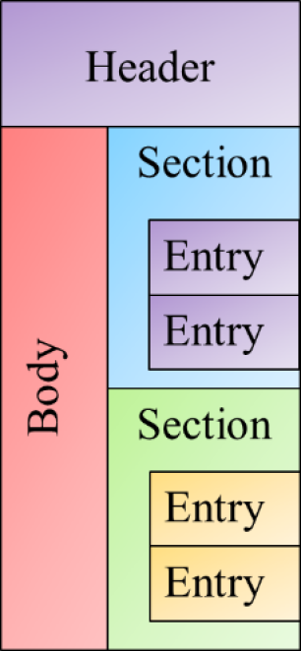
Figure 3 - Logical View of a CDA Document
- Header: Which contains data related to the document such as the subject (patient whose data is represented within the body), author, data enterer, custodian (original location of data), etc.
- Body: Which contains the content of the document. This content can be structured (as a structuredBody) or unstructured (as a nonXmlBody)
- Sections: Which represent major organizations of data such as advance directives, problems, allergies, medications, etc. These sections may or may not contain discrete data elements, however they must contain text which can be used by consumers to render content which they cannot semantically interpret.
- Entries: Which represent either a single data point (such as an observation, procedure, encounter, etc.) or logical grouping of data points (such as a battery, or medication regimen).
CDA consists of three levels of conformance describing the level of detail or semantic data contained within a document:
- Level 1: A level 1 CDA document consists of a structured header and an unstructured body. A Level 1 CDA document may convey PDF, RTF, HTML or proprietary other content which cannot be encoded by the content creator.
- Level 2: A level 2 CDA document consists of a structured header, and a structured body having codified sections. Sections carry a textual representation of the clinical data stored in the content creator classified by a code.
- Level 3: A level 3 CDA document consists of a structured header, a structured body having codified sections which are comprised of discrete data contained within entries. These entries contain data which can be semantically understood by the recipient of the document.
Level 3 is represents an extension of a Level 2 document and they are often interchangeable. For example, a consumer which only understands CDA at Level 2 (section import) can store a Level 3 document, conversely a consumer which implements Level 3 (discrete import) can still interpret a Level 2 document. Additionally some document templates will represent a mixture of level 2 and level 3 content, or may give the implementer a choice of using a level 2 section or a codified level 3 section.

SHR Implemented Section Templates of CDA
The SHR can import any CDA Level 2 section as a complex Obs having complex content. The sections identified in are registered as Level 3 sections, meaning any discrete data elements which they contain can be imported.
- Active Problems
- Advance Directives
- Allergies and Other Adverse Reactions
- Antenatal Testing and Surveillance
- Antepartum Visit Summary Flow sheet
- History of Infection
- Results
- Estimated Delivery Date
- Family Medical History
- History of Past Illness
- Immunizations
- Medications
- Physical Examination
- Pregnancy History
- Social History
- Vital Signs

Appendix 3: FHIR and XDS.b Functionality
The basic function of the FHIR RESTful API can be found here: http://www.hl7.org/implement/standards/fhir/http.html
In order to implement XDS.b like functionality a content handler module must support the following FHIR resources:
- DocumentReference
Typically, DocumentReference resources are used in document indexing systems, such as IHE XDS (see the XDS specific profile), and are used to refer to:
  - CDA documents in FHIR systems
  - FHIR documents stored elsewhere (i.e. registry/repository following the XDS model)
  - PDF documents , and even digital records of faxes where sufficient information is available
  - Other kinds of documents, such as records of prescriptions
- Patient
This Resource covers data about patients and animals involved in a wide range of health-related activities, including:
  - Curative activities
  - Psychiatric care
  - Social services
  - Pregnancy care
  - Nursing and assisted living
  - Dietary services
  - Tracking of personal health and exercise data
- Practitioner
Practitioner covers all individuals who are engaged in the healthcare process and healthcare-related services as part of their formal responsibilities and this Resource is used for attribution of activities and responsibilities to these individuals. Practitioners include (but are not limited to):
  - physicians, dentists, pharmacists
  - physician assistants, nurses, scribes
  - midwives, dietitians, therapists, optometrists, paramedics
  - medical technicians, laboratory scientists, prosthetic technicians, radiographers
  - social workers, professional home carers, official volunteers
  - receptionists handling patient registration
  - IT personnel merging or unmerging patient records
  - Service animal (e.g., ward assigned dog capable of detecting cancer in patients)
- Organization
This resource may be used in a shared registry of contact and other information for various organizations or it can be used merely as a support for other resources that need to reference organizations, perhaps as a document, message or as a contained resource. If using a registry approach, it's entirely possible for multiple registries to exist, each dealing with different types or levels of organization.

Reference:
- FHIR Document Interface Module

Extracted from What constitutes an OpenHIE SHR?
Policy considerations when connecting an application to OpenHIM
IHE’s Audit Trail and Node Authentication
Consent Management, OpenHIE Discussion Document Draft 0.1, Overview Page 3
Reference Interfacing with OpenSHR in the document Clinical Document Architecture Support for OpenSHR, for a brief overview of the OpenSHR implementation of XDS.
Refer to Our current reasoning about the choice of standards in Standards for the Shared Health Record
Consent Management Draft 0.1 (OpenHIE Discussion Document), Derek Ritz, 2015-04-13
From Wiki page SHR - Use Cases and Requirements

